Project Proposal – Database Systems

Valorant Competitive Intelligence System

Team number: 30
Student names: Sylvester Soo Wei Xuan, Tan Sze Loke Aldric, Aloysius Tan, Yeo Jessa Jenny Corrales, Tan Dexter

01/10/2026

Application Description
The application is a Valorant scouting and match preparation platform that allows users to view team, player and match statistics, while providing deeper analysis of opponents using round-level data. The background is that existing statistics platforms such as VLR.gg mainly provide high-level information such as recent results and map performance. The problem is these statistics provide limited insight into how teams actually play and recurring gameplay patterns. The objective is to provide teams with a clearer understanding of their opponents’ strength and weakness, and data-driven suggestions for suitable maps and agent compositions.

System Architecture
The application follows a 3-tier architecture consisting of a Streamlit presentation layer, Python application layer, and data layer. The Python backend handles queries, filtering, analysis and recommendations, while PostgreSQL stores structured relational data and MongoDB stores detailed round-level data.
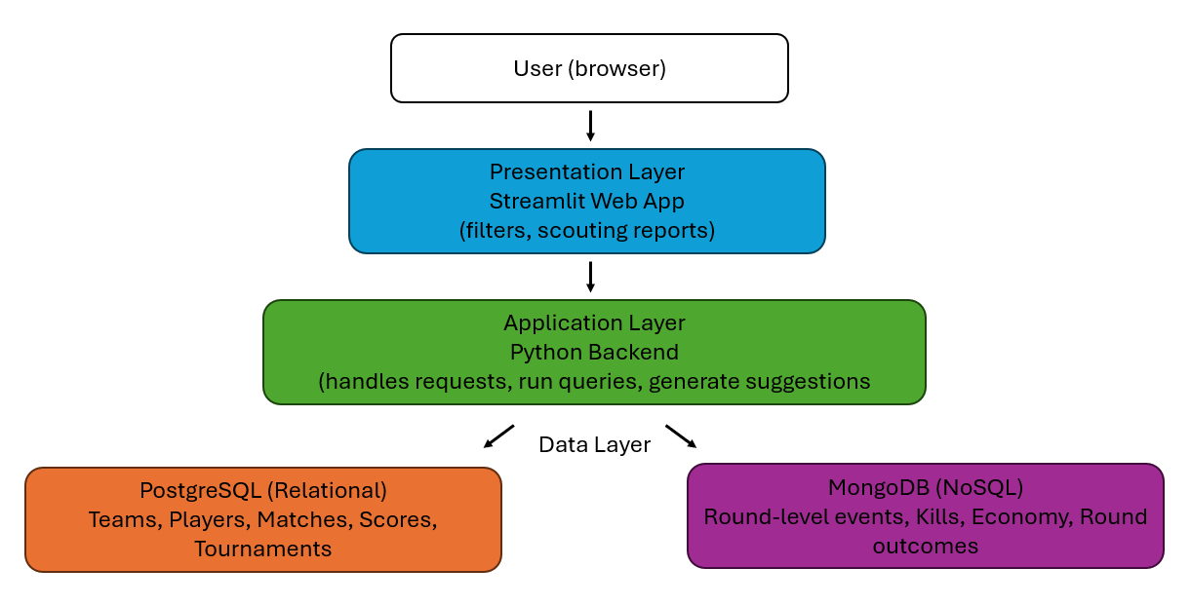

Data
The project uses a publicly available Valorant Champions Tour (VCT) dataset downloaded from Kaggle. The dataset contains tournament, stage, match, team, player, map, agent, player-statistics and round-level data. Structured data will be stored in PostgreSQL and represented using the ERD below. Detailed round-level data, such as economy, kills and round outcomes, will be transformed into nested MongoDB documents, with each game containing its related round information.
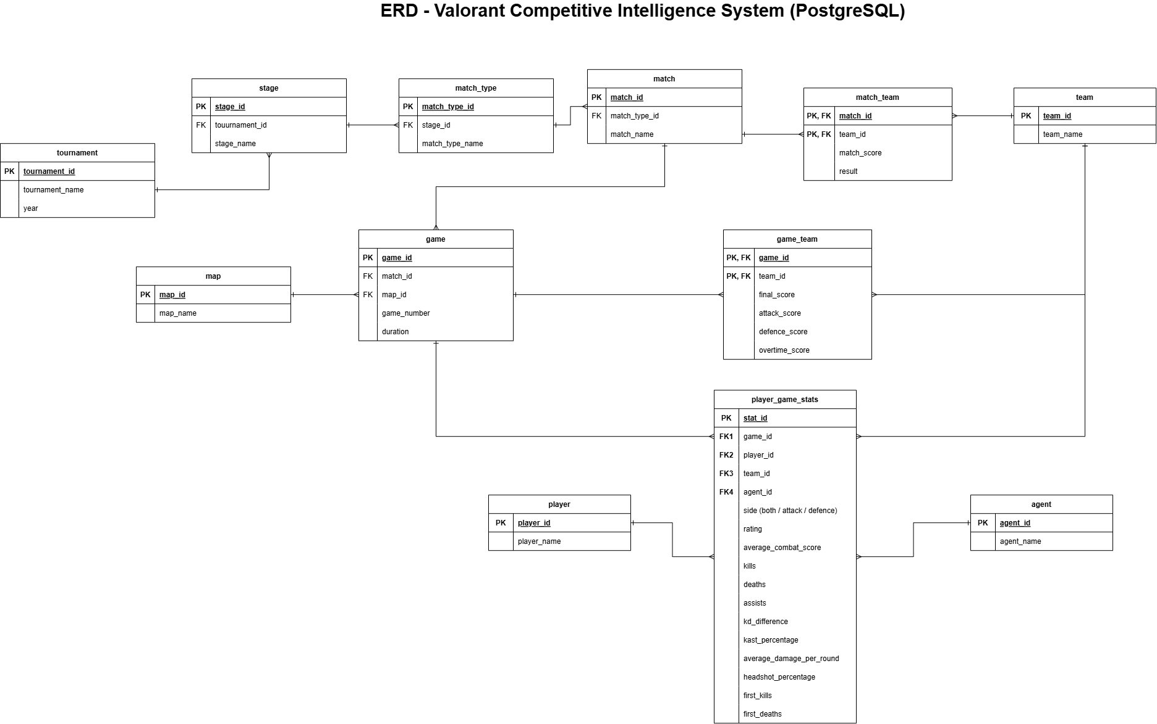
Nested MongoDB data diagram
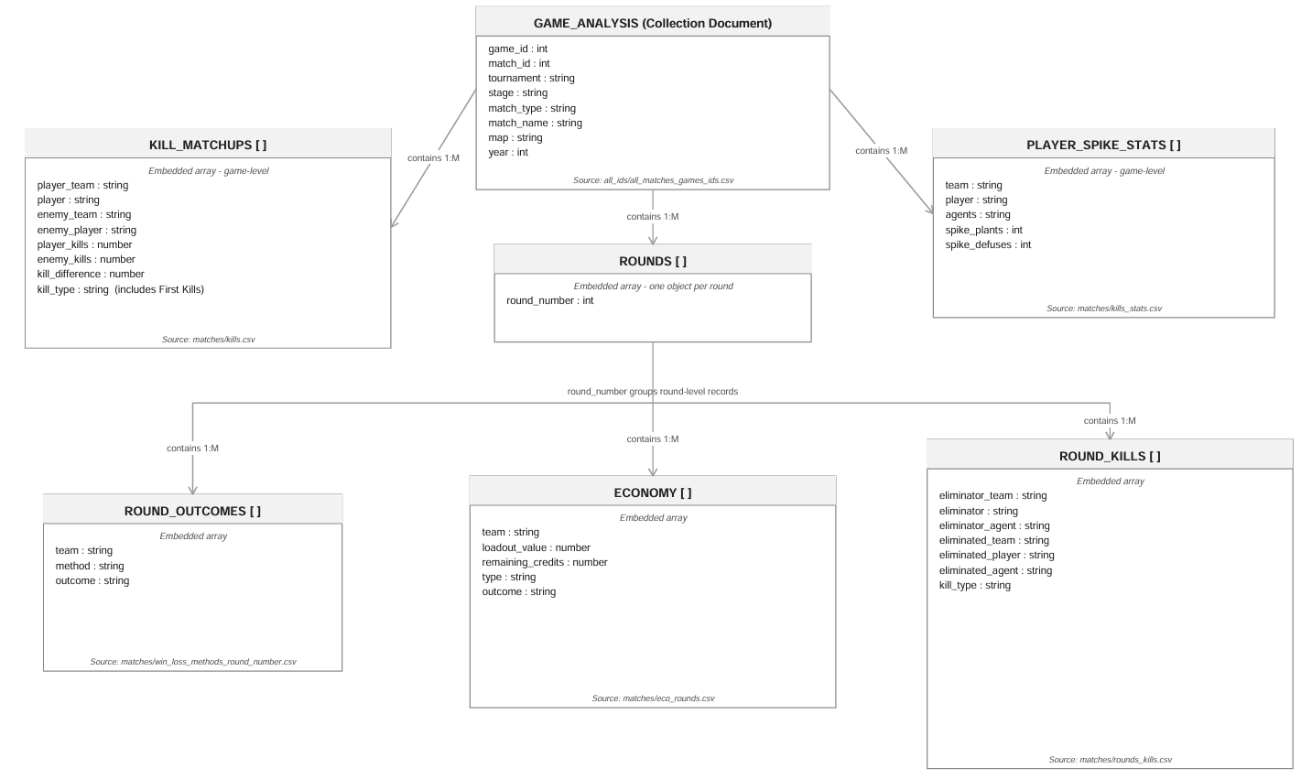
Functionalities and Implementation Plan
The application will provide team, player and match statistics, detailed match analysis, and a scouting feature with filters such as tournament and map. The scouting feature will analyse map performance, agent usage, player trends and round-level data, and provide data-driven map and agent composition suggestions. Basic CRUD functions will also be included.
Implementation will involve data cleaning, database design and setup in PostgreSQL and MongoDB, followed by Python backend development, Streamlit integration, testing and refinement.
Current Deliverables
Project scope and core features are defined, the VCT dataset (Kaggle) has been obtained, and database/architecture planning is underway."

References
[1] https://www.kaggle.com/datasets/ryanluong1/valorant-champion-tour-2021-2023-data
[2] Valorant esports coverage | VLR.gg

